**Lab Number: 10 Date: 2025/08/17**

**Title: Implementation of Dynamic Interior/ Exterior Routing (RIP, OSPF, BGP)**

**Theory:**

1. **Dynamic Interior Routing/ Exterior Routing**

Dynamic Interior Routing involves the automatic handling and updating of routes within a single Autonomous System (AS). It allows within the same network or organization to share information and determine the optimal path to a destination. Several interior routing protocols are commonly used to achieve this, including RIP (Routing Information Protocol), OSPF (Open Shortest Path First) and EIGRP (Enhanced Interior Gateway Routing Protocol).

Dynamic Exterior Routing focuses on managing routing between different Autonomous Systems (ASes), enabling routers to share information across the boundaries of various networks or organizations. This type of routing is essential for communication on the Internet, where exterior routing protocols are used to connect different ASes. The primary protocol for this purpose is BGP (Border Gateway Protocol), which is the standard exterior routing protocol. BGP maintains routing information between ASes, ensuring efficient data transfer across networks on a global scale.

1. **RIP, OSPF, BGP**

**RIP:** Routing Information Protocol (RIP) is a distance-vector routing protocol that selects the best route based on hop count. It has a maximum hop count limit of 15, making it most suitable for smaller networks. Although it is easy to set up, RIP has slow convergence and lacks the scalability needed for larger or more complex networks.

**OSPF:** Open Shortest Path First (OSPF) is a link-state routing protocol that uses the Dijkstra algorithm to determine the shortest path. OSPF is well-suited for large networks as it supports hierarchical structuring by splitting the network into areas. It offers faster convergence, advanced features like route summarization, and supports variable-length subnet masks, though it is more challenging to configure than RIP.

**BGP:** Border Gateway Protocol (BGP) is a path-vector routing protocol primarily used for routing between different autonomous systems, such as ISPs (Internet Service Providers) and large organizations. BGP focuses on policy-based routing, making it crucial for managing traffic across the internet. It is highly scalable but requires more careful and complex configuration due to its slower convergence compared to internal protocols like OSPF.

1. 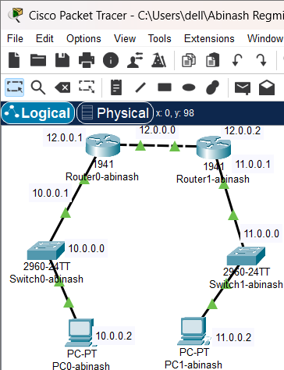**Network Diagram**

Fig: Network Diagram

**Implementation Sequence**

Here is the implementation sequence for Implementation of Dynamic Interior/ Exterior Routing (RIP, OSPF, BGP).

1. **Configuring Network**

**Configure the network for PCs and Routers**

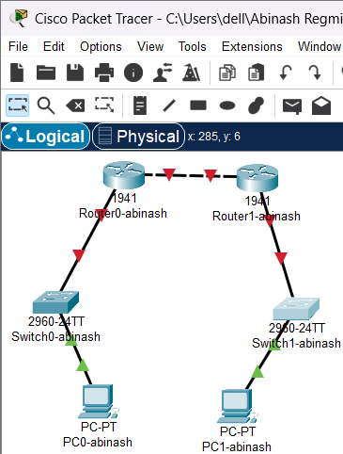**Step 1: Open Packet Tracer and setup the devices.**

fig: Simple Network setup

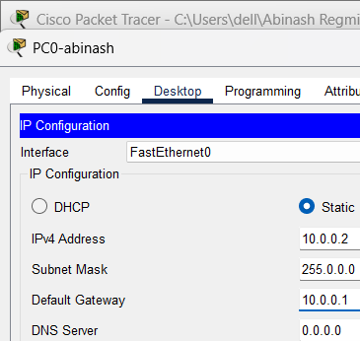**Step 2: Assign IP addresses to each PC.**

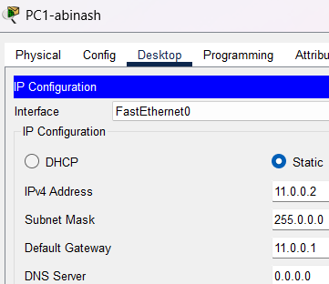

Fig: IP configuration

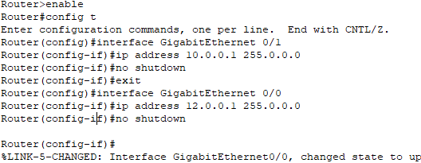**Step 3: Assign IP addresses to router interfaces.**

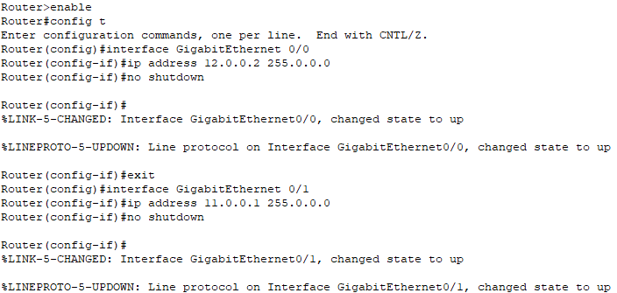Fig: Gigabit Ethernet configuration on router0

Fig: Gigabit Ethernet configuration on router1

**Implementation & explain the need for Dynamic Routing**

**Implementation of Dynamic Routing:** Dynamic routing protocols, such as RIP, OSPF, and BGP, are used to enable routers to automatically exchange and update routing information based on changes in the network. The implementation process involves:

* **Network Configuration:** Set up our network by configuring routers and PCs, and assign IP addresses to each device.
* **Dynamic Routing Setup:** Enable the chosen dynamic routing protocol (RIP, OSPF, or BGP) on each router. This allows routers to automatically share and update routing information.
* **Testing:** Use tools like ping to verify that the network configuration is correct and that connectivity is established across the routers.

**Need for Dynamic Routing:** Dynamic routing is crucial for modern networks due to the following reasons:

* **Automatic Route Updates:** As network conditions change-such as when links fail or new devices are added-dynamic routing protocols automatically update the routing tables. This keeps the network connected without requiring manual adjustments.
* **Scalability:** In large or rapidly changing networks, manually configuring static routes can be impractical. Dynamic routing protocols handle the growth of the network efficiently, making it easier to scale.
* **Efficient Path Selectin:** Dynamic protocols continuously evaluate network conditions and choose the best path for data. This helps in optimizing performance and reducing delays.
* **Redundancy and Fault Tolerance:** These protocols improve network reliability by quickly adapting to failures and rerouting traffic through alternative paths, minimizing downtime.
* **Improve Load Balancing:** Dynamic routing protocols can distribute network traffic evenly across multiple paths. This load balancing ensures that no single path is overloaded, enhancing overall network efficiency overall network efficiency and performance.

1. **Dynamic Routing Configuration**
2. **Using RIP Command**

**Network Diagram**

fig: Network Diagram

**Code for Dynamic Routing Configuration using RIP command**

**For Router 0**

Router>enable

Router#configure terminal

Router(config)#router rip

Router(config-router)#version 2

Router(config-router)#network 10.0.0.0

Router(config-router)#network 12.0.0.0

Router(config-router)#exit

**For Router 1**

Router>enable

Router#configure terminal

Router(config)#router rip

Router(config-router)#version 2

Router(config-router)#network 12.0.0.0

Router(config-router)#network 11.0.0.0

Router(config-router)#exit

**Steps for Dynamic Routing Configuration using RIP Command**

**Step 1: Access the Router CLI**

* Open Packet Tracer
* 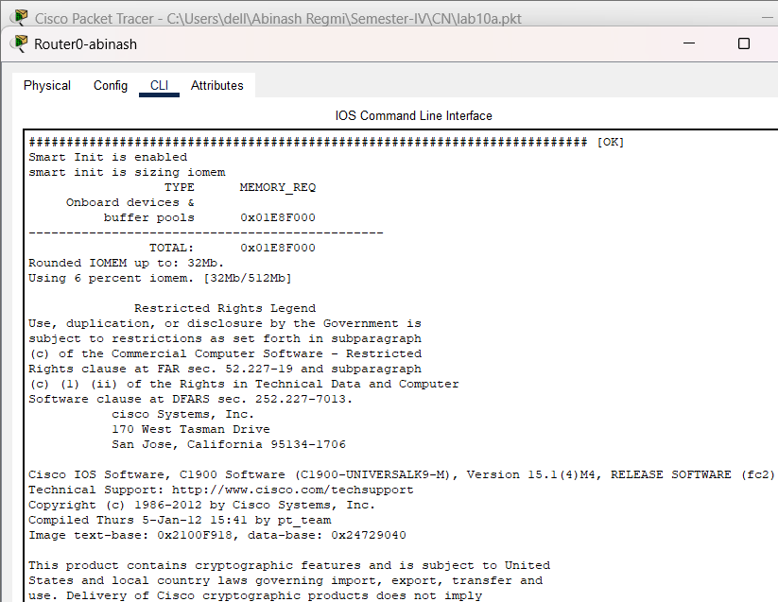Click on the router we want to configure to access its CLI (Command Line Interface).

fig: Accessing Router CLI via Console Cable

**Step 2: Enter Global Configuration Mode**

* Enable RIP Routing Protocol
* Specify the RIP Version
* Configure the RIP Networks
* 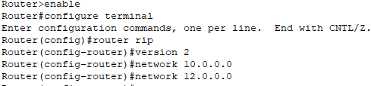Exit RIP Configuration Mode

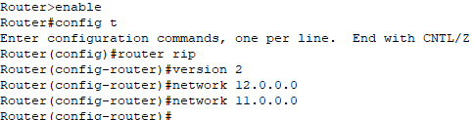

Fig: Router configuration of router0 and router1 using RIP command

**Testing**

To test whether the network is working, we can ping other devices on the network from each PC. If the ping is successful, we should see replies from the other device.

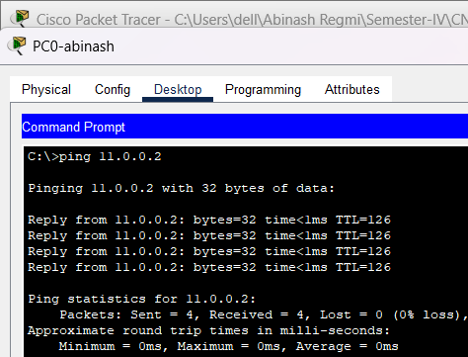

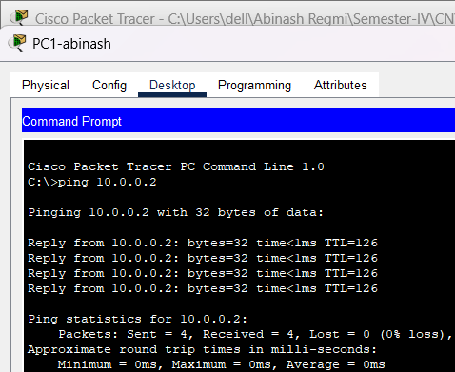Fig: Connectivity test from PC0-abinash to PC1-abinash

Fig: Connectivity test between PC1-abinash to PC0-abinash

Above figure shows the results of a ping test between two PCs on a network. The ping test was successful, indicating that there is connectivity between the two devices. The output of the ping test shows the number of packets sent, received, and lost, as well as the approximate round trip time for each packet.

**Using OSPF Command**

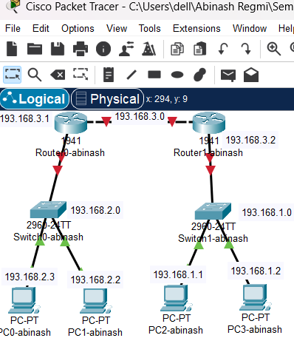**Network Diagram**

Fig: Network Diagram

**Code for Dynamic Routing Configuration Using OSPF Command**

**For Router0**

Router>enable

Router#config t

Router(config)#router ospf 1

Router(config-router)#network 193.168.1.0 0.0.0.255 area 0

Router(config-router)#network 193.168.3.0 0.0.0.255 area 0

Router(config-router)#exit

**For Router1**

Router>enable

Router#config t

Router(config)#router ospf 2

Router(config-router)#network 193.168.2.0 0.0.0.255 area 0

Router(config-router)#network 193.168.3.0 0.0.0.255 area 0

Router(config-router)#exit

**Steps for Dynamic Routing Configuration using OSPF command**

**Step 1: Access the Router CLI**

* Open Packet Tracer.
* 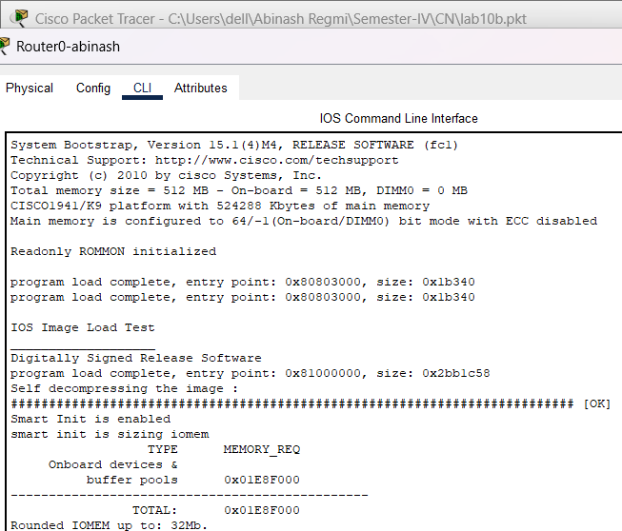Click on the router we want to configure to access its CLI (Command Line Interface).

Fig: Accessing Router Command-Line Interface via Console Cable

**Step 2: Enter Global Configuration Mode**

* Enable OSPF Routing Protocol
* Start the OSPF process and assign it a process ID
* Assign a router ID
* Specify the networks connected to Router 1, and define the areas.
* 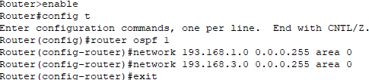Exit OSPF configuration.

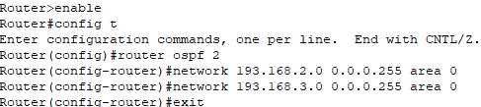

Fig: Router configuration for router0 and router1 using OSPF command

**Testing**

To test whether the network is working, we can ping other devices on the network from each PC. If the ping is successful, we should see replies from the other device.

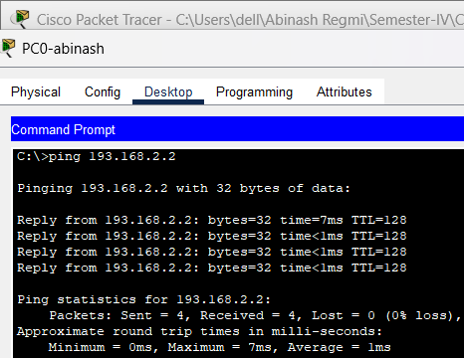

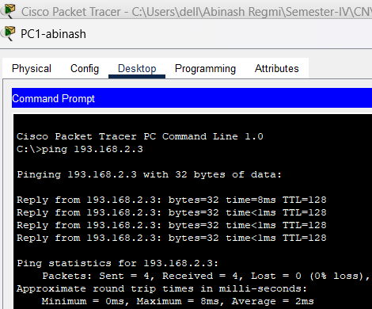Fig: Connectivity test from PC0-abinash to PC1-abinash

Fig: Connectivity test from PC1-abinash to PC0-abinash

Above figure shows the results of a ping test between two PCs on a network. The ping test was successful, indicating that there is connectivity between the two devices. The ping output of the ping test shows the number of packets sent, received, and lost, as well as the approximate round trip time for each packet.

**Addressing Table:**

The addressing table of the OSPF configuration is as follows:

|  |  |  |  |  |
| --- | --- | --- | --- | --- |
| Device | Interface | IPv4 Address | Subnet | Router no. |
| PC0 | NIC | 193.168.2.3 | 255.255.255.0 | 0 |
| PC1 | NIC | 193.168.2.2 | 255.255.255.0 | 0 |
| PC2 | NIC | 193.168.1.1 | 255.255.255.0 | 1 |
| PC3 | NIC | 193.168.1.2 | 255.255.255.0 | 1 |

**Using BGP Command**

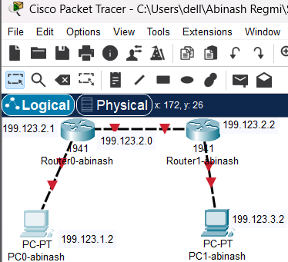**Network Diagram**

Fig: Network Diagram

**Code for Dynamic Routing Configuration Using BGP Command**

**For Router 0**

Router0> enable

Router0# configure terminal

Router(config)# router bgp 420

Router(config-router)# network 199.123.1.0

Router(config-router)# network 199.123.2.0

Router(config-router)# neighbor 199.123.2.2 remote-as 520

Router(config-router)# neighbor 199.123.3.2 remote-as 520

Router(config-router)# exit

**For Router1**

Router0> enable

Router0# configure terminal

Router(config)# router bgp 420

Router(config-router)# network 199.123.1.0

Router(config-router)# network 199.123.2.0

Router(config-router)# neighbor 199.123.2.1 remote-as 520

Router(config-router)# neighbor 199.123.1.2 remote-as 520

Router(config-router)# exit

**Steps For Dynamic Routing Configuration Using BGP Command**

**Step 1: Access the Router CLI**

* Open Packet Tracer
* 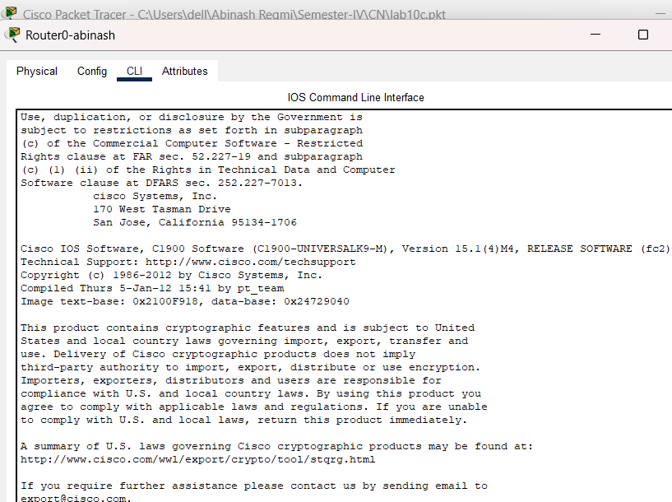Click on the router we want to configure to access its CLI (Command Line Interface).

Fig: Accessing Router CLI via Console Cable

**Step 2: Enter Global Configuration Mode**

* Enable BGP Routing Protocol
* Start the BGP process and specify the AS number
* Configure Neighbor
* Advertise Networks
* 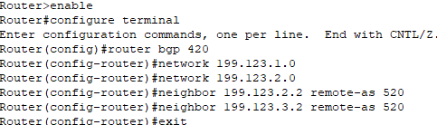Exit BGP configuration

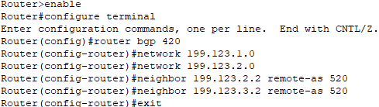

Fig: Router configuration for router0 and router1 using BGP command

**Testing**

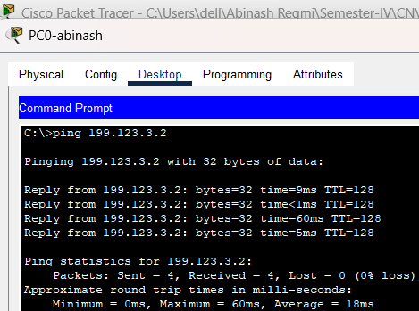To test whether the network is working, we can ping other devices on the network from each PC. If the ping is successful, we should see replies from the other device.

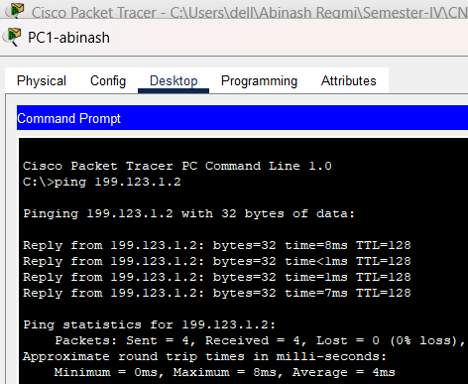Fig: Connectivity test from PC0-abinash to PC1-abinash

Fig: Connectivity test from PC1-abinash to PC0-abinash

Above figure shows the results of a ping test between two PCs on a network. The ping test was successful, indicating that there is connectivity between the two devices. The output of the ping test shows the number of packets sent, received, and lost, as well as the approximate round trip time for each packet.

**Addressing Table:**

The addressing table of the BGP Configuration is as follows:

|  |  |  |  |  |  |
| --- | --- | --- | --- | --- | --- |
| Device | Interface | IPv4 Address | Subnet | Router  No | Link |
| PC0 | NIC | 199.123.1.2 | 255.255.255.0 | 0 | Access |
| PC1 | NIC | 199.123.3.2 | 255.255.255.0 | 1 | Access |

**Conclusion**

In this lab, we implemented dynamic routing protocols RIP, OSPF and BGP to automate route updates and maintain efficient network connectivity. RIP’s simplicity makes it suitable for smaller networks, while OSPF’s faster convergence and scalability handle larger, more complex networks effectively. BGP plays a crucial role in exterior routing, managing inter-AS communication and supporting global internet traffic. Through successful ping tests, we verified proper network configuration and confirmed the seamless operation of these protocols.